User’s Manual
Gas and Carbon Monoxide Alarm

Model: RC412COM
Please read particulars before you use it.
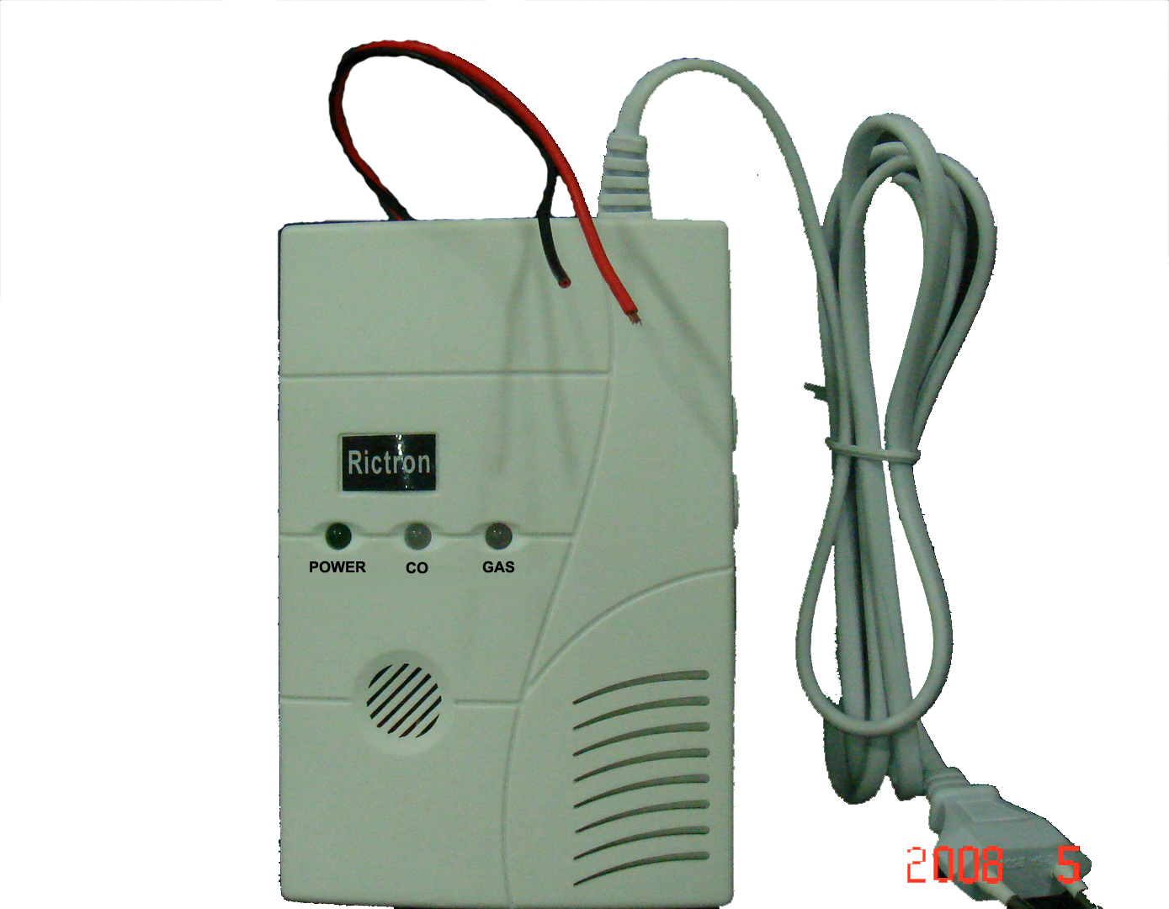
1
2
3
4
5
6
7

1. Green LED light: Power
2. Two-tone LED Light: Co
3. Two-tone LED Light: Gas
4. Test Button
5. Hush Button
6. AC Power Supply
7. Output relay (12VDC) Red Wire connects with anode and black for cathode. (RC412COM-V is also available)
TECHICAL PARAMTER
FEATURES:
* Excellent reliability & high stability.
* Durable sensor head.
* Self test function
* Visual and audible alarm function
* Low voltage warning
* Sensor-fault detection
* Can be connected with valve
* Hush function in alarm status
* Less affected by other organic solvent.
* Loud sound signal of 85 dB at alarm mode.
* Three-year limited warranty.
* Low power consumption
* Test button to test the units electronics and verifies proper unit operation.
* Easy installation with a plastic bracket.
* Widely use for home, coal station, colliery, car and so on.
* Detect all sorts of combustible gases, such as coal gas, liquid petroleum gas and natural gas, carbon monoxide and monitor automatically.
SECIFICATION:
* Power supply: AC220V/50~60Hz& 9v backup battery
* Sensor: Electrochemistry Co and Gas
* Static current: ≤40MA
* Alarm current: ≤80MA
* Static consume: ＜0.6 W
* Alarm consume: ＜2W
* Alarm volume: ≥85dB within 1 meter
* Operation Ambient Condition: 4~38℃, 25~85%R.H.
* Alarm density:
Carbon monoxide:
50PPM: 60-90 minutes
100PPM: 10-40 minutes
300PPM: less than 3 minutes
400PPM: Immediately
Coal gas: 1000~5000ppm,
Liquid petroleum gas: 1000~5000ppm,
Natural gas: 1000ppm~5000ppm
*.Responding time: Gas ≤30S
*.Alarm output: frequent on or off signal, control exhaust fan, electrical magnetic valve signal.
INSTALLATION GUIDE
Accord to specific gravity of natural gas to install gas leakage alarm, Natural gas and coal gas and Carbon monoxide: its specific gravity is lighter than air, so it suspends on the ceiling. Therefore, the alarm should be installed in the area that is less 0.3~ 1.2 meters than the ceiling and within radii 1.5 meter far from gas leakage.
Liquid petroleum gas: its specific gravity is heavier than air, so it sinks down on the bottom. Therefore, the alarm should be installed in the area that is 0.3~ 1.2 meters far from ground and within radii 1.5 meter far from gas leakage.
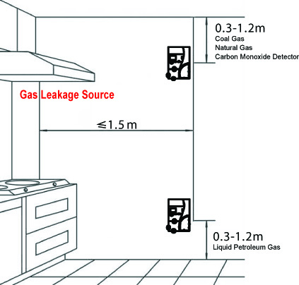

Required to attention:
- Do not face it to oil smoke and steam of cooking range
- Do not install it at the airless area
- Do not be obstructed by window curtain or cabinet
- Do not install it at the area with heavy vapor , such as washing room
OPERATION GUIDE
1. FUNCTION INTRODUCTION
Power: When connecting with power supply AC 220V, the unit may sound for several minutes, then stop and enter in normal operation mode with green Power LED on. It means the alarm is activated. If it always sounds, please call our agent.
Alarm: The red LED turns on when the alarm sounds, and it is also normal for both two lights turn on when you press the Test Button.
Fault: If there is something wrong with Gas or Co sensor, the relevant LED would turn into orange and go with beep sound.
Test: Test the detector, press the Test button. It gives out alarm warning. Both Gas and Co LED will auto turns into red together and after a few second it turns off.
2. ALARM AND FAULT STATES
Gas LED and CO LED are both Two-Tone LED
Red LED
Red LED indicates the alarm.
When Gas is detected, Gas LED will flash in red with the alarm beep.
When Carbon monoxide is detected, Co LED will flash in red with the alarm beep.
Orange LED
Orange LED indicates sensor fault.
If Co LED turns into orange and go with beep sound, it shows Co sensor is faulty.
If Gas LED turns into orange and go with beep sound, it shows Gas sensor is faulty.
3. TEST
Press the test button for several seconds to test unit’s electronics. The alarm will sound. In test states, the Gas LED and Co LED all flash in red with beep sounds.
4. HUSH FUNCTION
It enters into Silence model for 5—7 minutes after pressing “HUSH BUTTON” during alarm model.
ALARM SOLUTION
When the alarm giving an alarm warning such as red indicator turned on or buzzer sounds, alarm solution is needed immediately:
- Shut off wipe valve of natural gas.
- Open all window to let gas out of room
- Do not touch any electrical switch, plug, telephone or door ring
- Do not use match or lighter. Turn off all fire immediately
- Do not test the gas leakage with fire
- Do not shut off the alarm power because the alarm will automatically stop alarming once gas leakage disappeared
- Check off the gas leakage source and immediately notify gas supply to send professional technician to repair.



